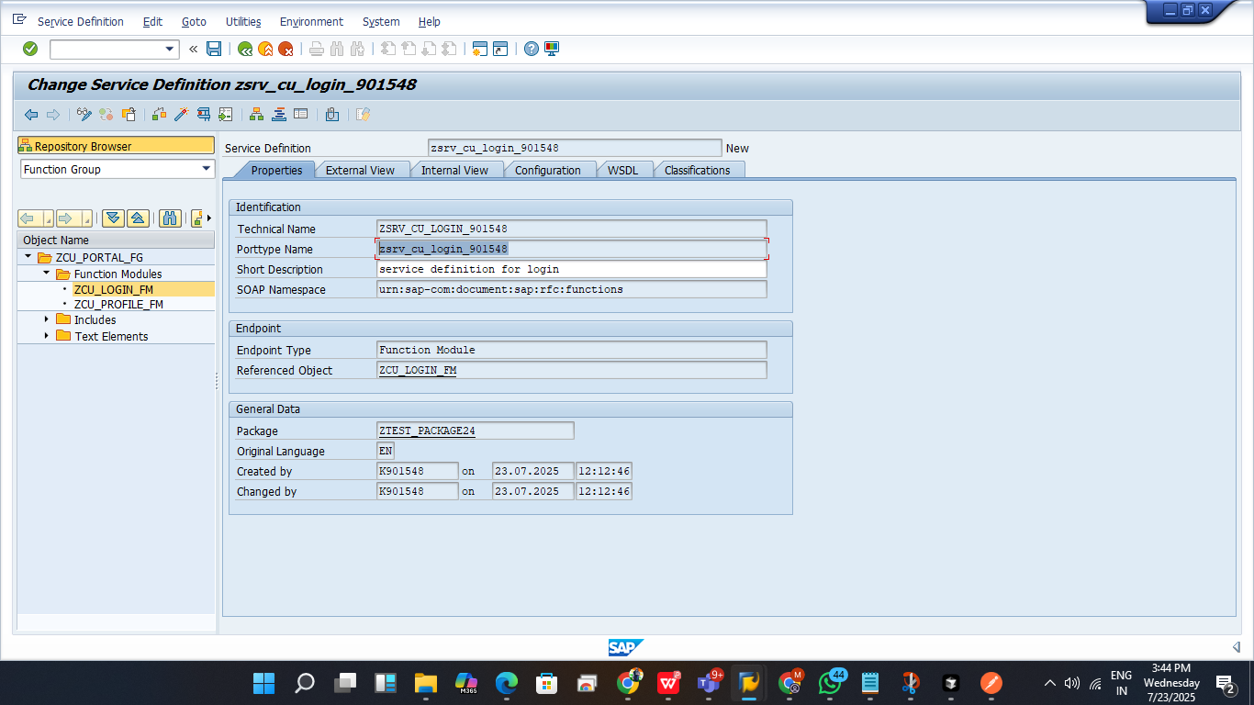

This is the main thing we want to enter in to this

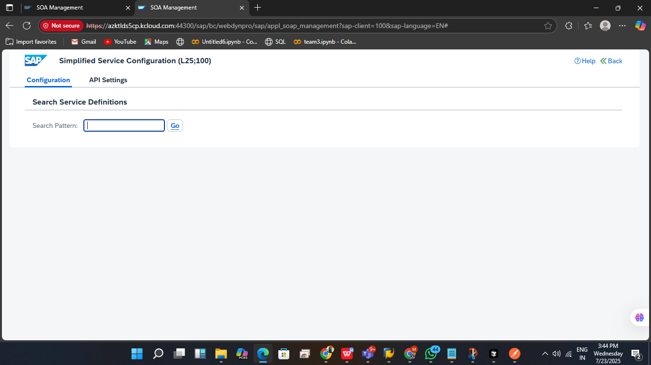

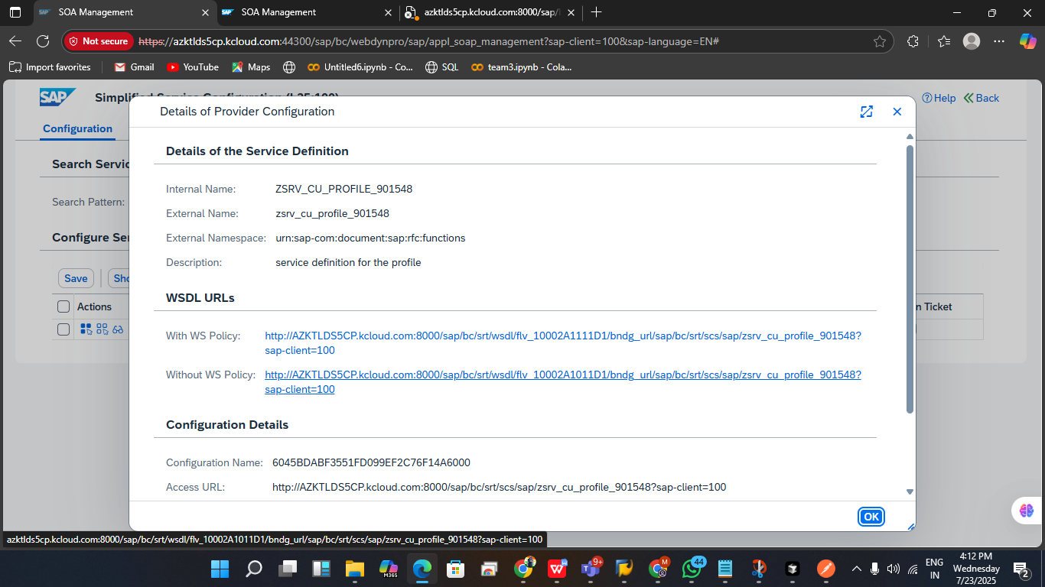  
  
  
wsdl link and acceess url link for postman checking and api request for profile

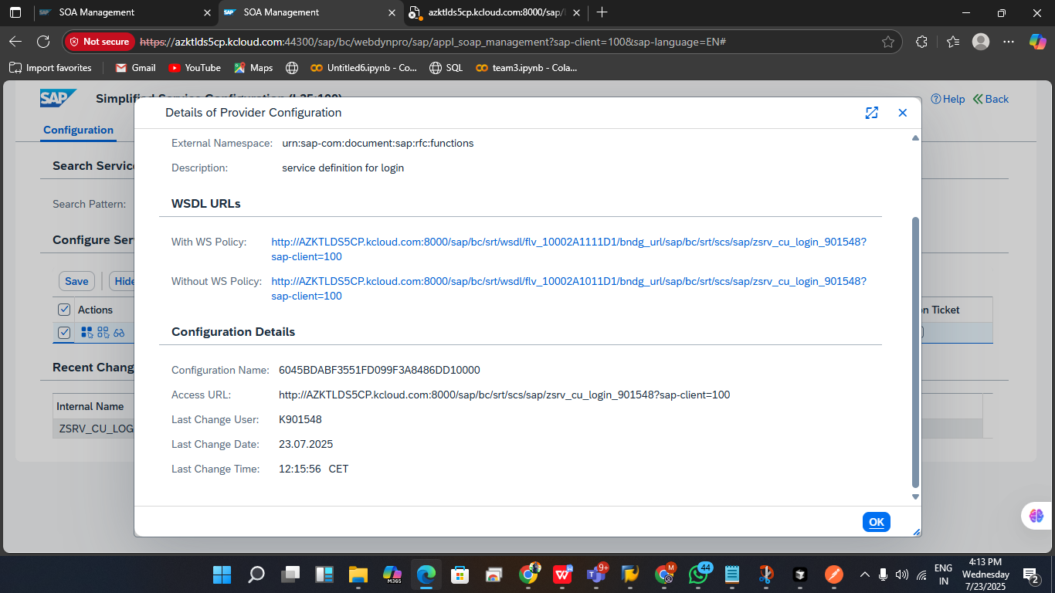

wsdl link and acceess url link for postman checking and api request for login

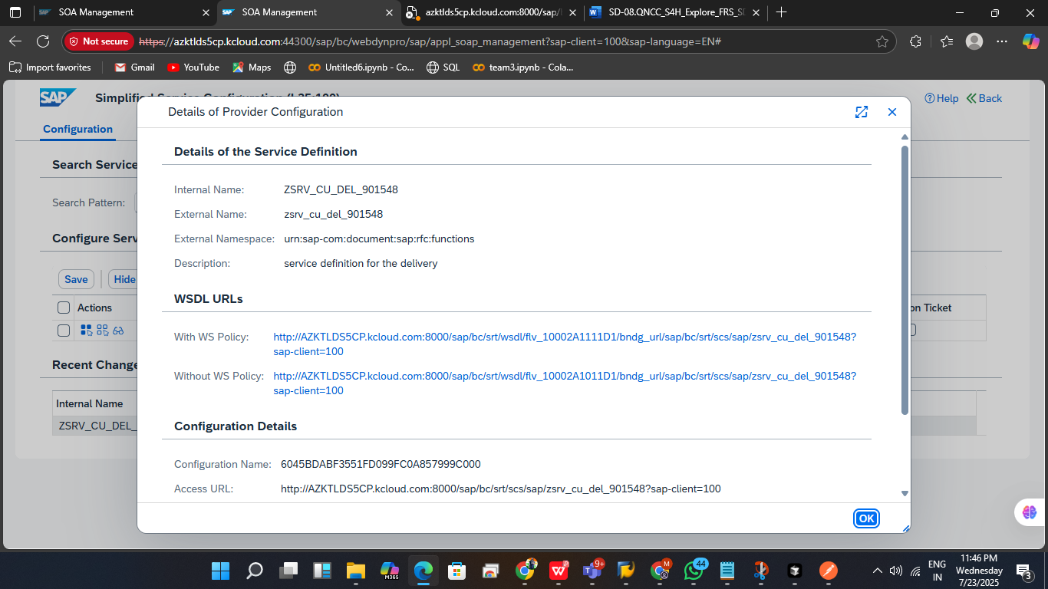

wsdl link and acceess url link for postman checking and api request for delivey.

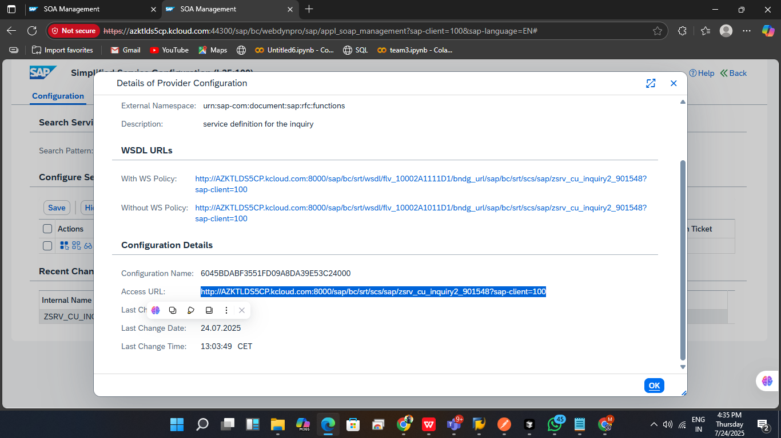

wsdl link and acceess url link for postman checking and api request for inquiry.

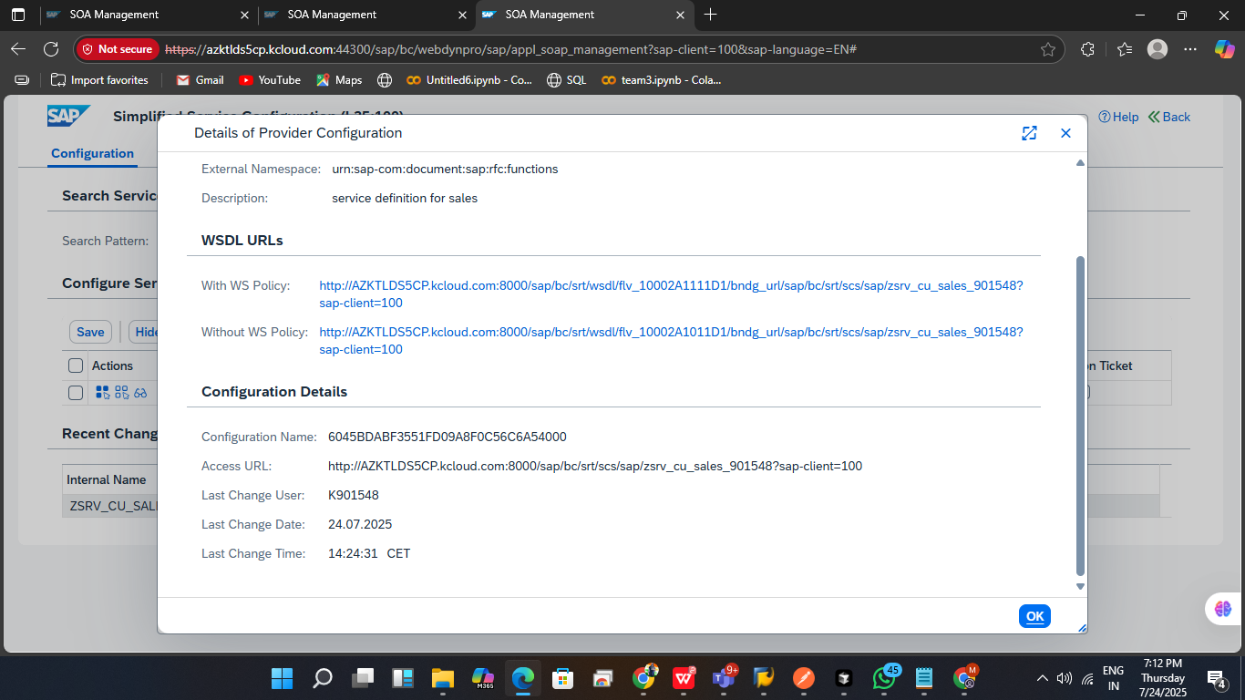’

wsdl link and acceess url link for postman checking and api request for sales.

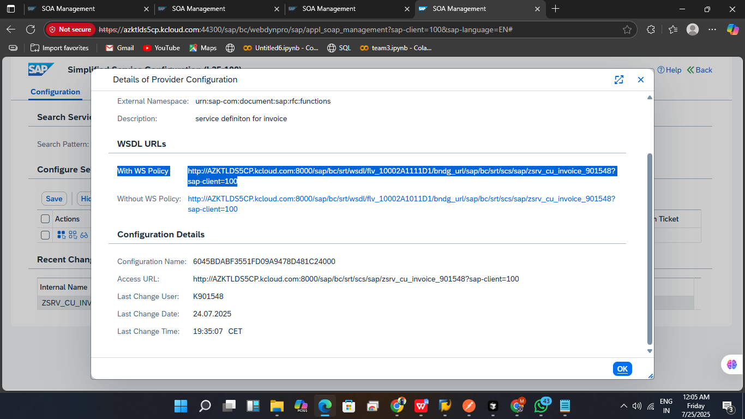

wsdl link and acceess url link for postman checking and api request for invoice.

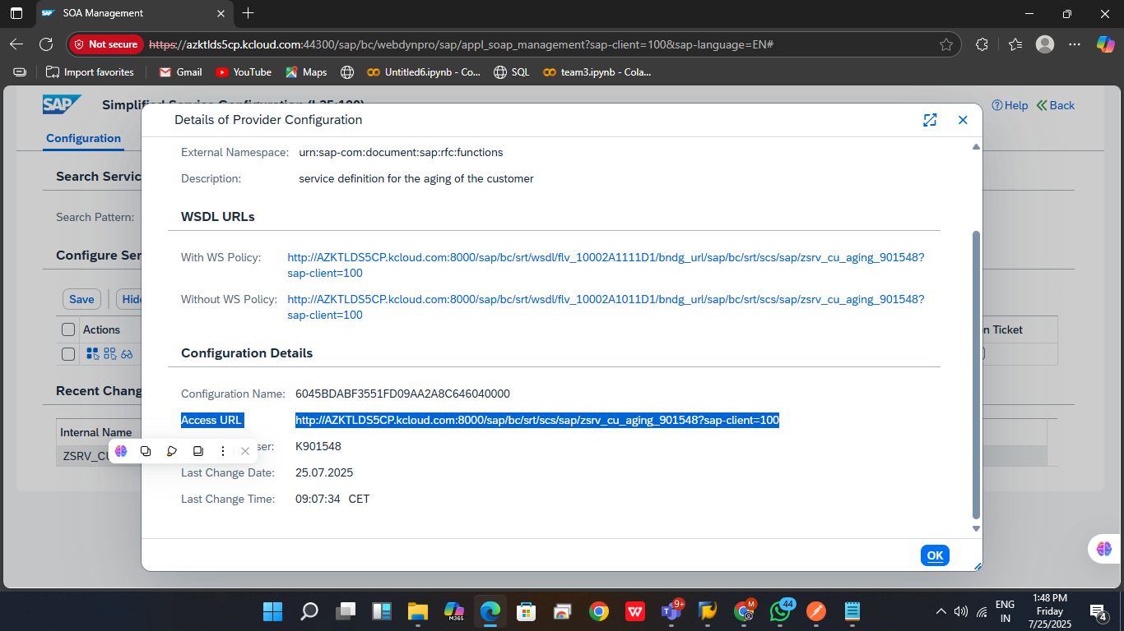

wsdl link and acceess url link for postman checking and api request for aging.

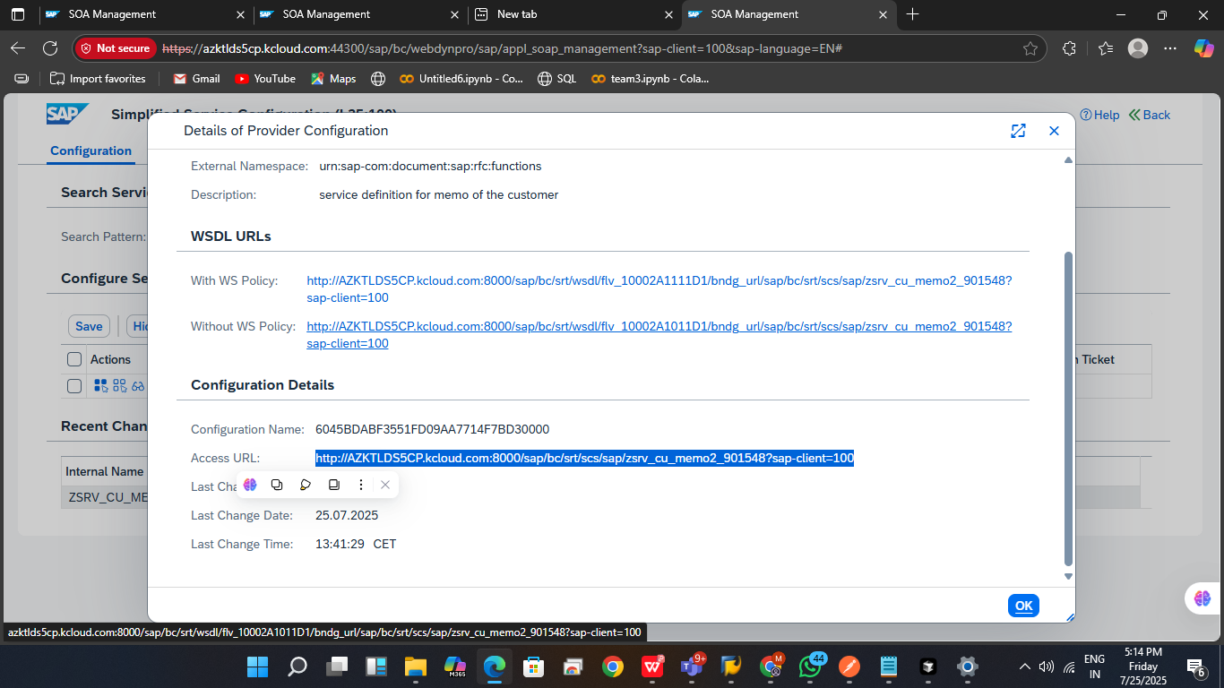

wsdl link and acceess url link for postman checking and api request for memo